REVISION HISTORY

DATE | REVISION No | BY | CHANGE DESCRIPTION
29/01/2019 | 01 | DP | New

TOOL LIST

DESCRIPTION | CALIBRATION | REF / TOOL No
Drill M/C | N/A
3mm, 5.5mm,7mm,8mm, 9.5mm and 11mm Drill bits | N/A
Digital Scale | N/A

Caution: Static Sensitive Device – Handle in accordance with Standard
Operators MUST wear ESD Foot straps for Standing / Walking operations
and / or ESD Wrist straps for Seated operations

ESD precautions apply within this process where this symbol is displayed



Operation DESCRIPTION | Proximity Sensor | STAGE No.

PROCESS DESCRIPTION

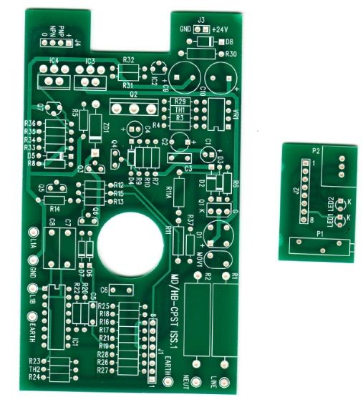 | 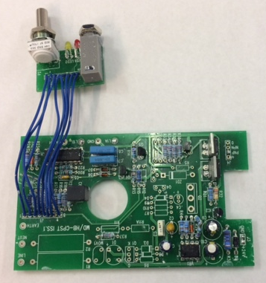
Populate the PCB, 24VDC or 100VAC as per requirement using BOM parts list. | Once populated PCB then test with coil to make sure that PCB is correctly working
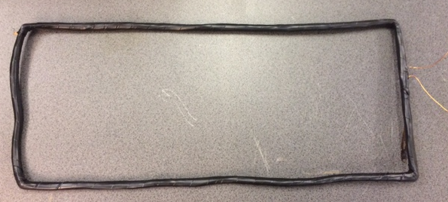 | 
Make coil. Use Single Core 0.56mm diameter Copper enamelled Wire, size 330 x 140mm 80 turns (RS P/N: 357-750). If you have different size case then coil size will depend on case length and width but coil turns still will be 80 turns. | Put approximately 12mm silver foil tape around the bottom side of the case. DO NOT join ends. Solder blue colour wire on Copper tape and then on the silver foil tape for ground. Nearest side where the Pcb is.
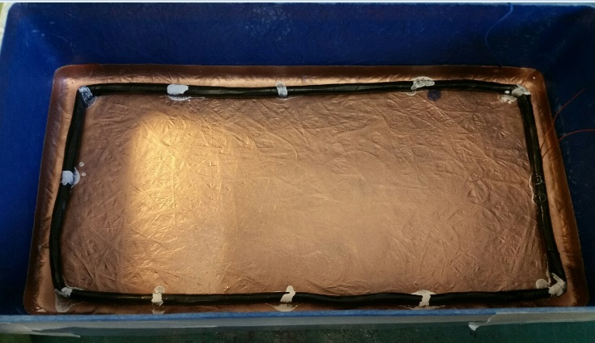 | 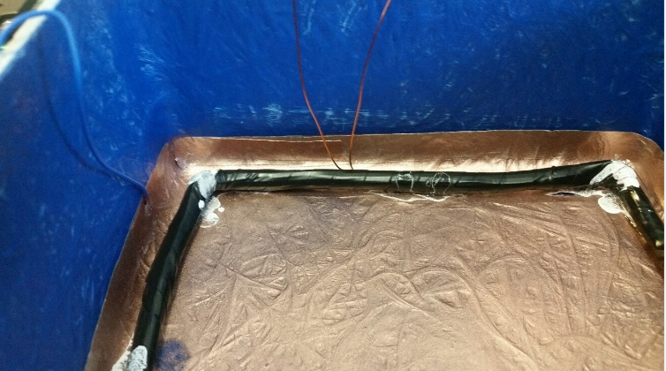
Place masking tape all four side above the silver foil tape. Then Spray with EMI/RFI “Silver coated copper Screening compound” (RS P/N: 247-4251) | Once it’s dry. Fit the coil and stick with superglue. Making sure the coil wires are at the end with the cut in the Silver foil and Blue GND wire. Wire up Test the PCB board with coil before potting.

PROCESS DESCRIPTION

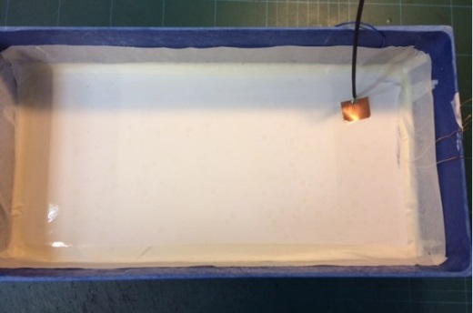 | 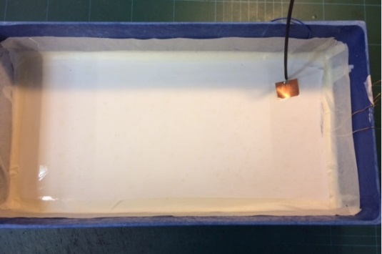
Mix the hard potting. 600g Potting compound and 180g Activator. Pour into bag and mix until it feels warm. Then pour into case till cover coil. Make sure that coil and ground wires are outside not stuck inside the potting. | Once potting is Dry and Hard, get the small piece of copper foil tape and solder Green/yellow wire and stick on Hard potting  Note: There are two separate ground wires. One comes out from silver foil on the edge and other from on top of the hard potting.
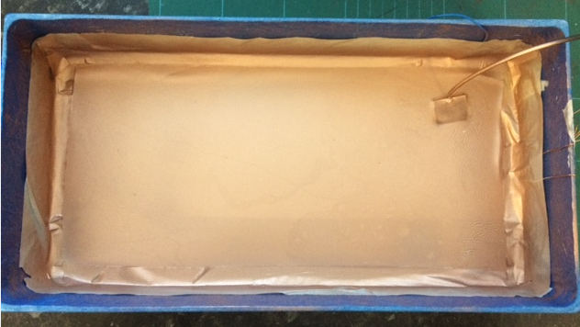  Spray with “Silver coated copper Screening compound | 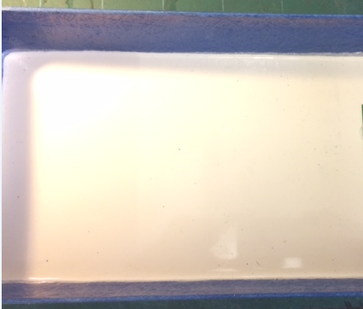
Place masking tape around the edge to cover silver foil tape and about ½” on hard potting from the side. Then Spray with EMI/RFI “Silver coated copper Screening compound” (RS P/N: 247-4251) in centre part of the hard potting. Make sure that both grounds are NOT shorting together. | Once it’s dry. Remove Masking tape and make up 200g Soft Potting compound and 40g Activator in a Bag and mix until it feels warm. Then pour into case until it covers the EMI/RFI “Silver coated copper Screening compound” (RS P/N: 247-4251) in centre part of the hard potting. This will be an only thin layer of potting.
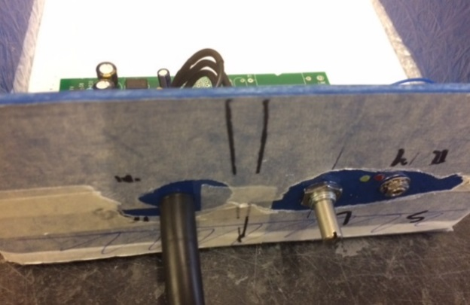 | 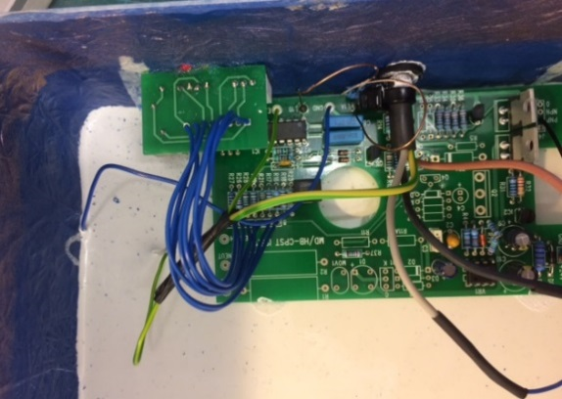
Once Potting hardened and dry to touch. Mark up case for PCB Pot’s, led’s and cable outlet holes. Then drill the holes. Take care when drilling holes.  2 x 9.5mm for 5k Pot and cable, 2 x 3mm for LEDs 1 x 8mm for 20k Coarse pot | Connect coil wires and both grounds as per board marking/drawing. The blue ground wire needs to be connected on GND point between two coil wire and Green/Yellow Earth wire needs to be connected with the supply Earth wire and PCB Earth point near the IC as per above picture.

PROCESS DESCRIPTION

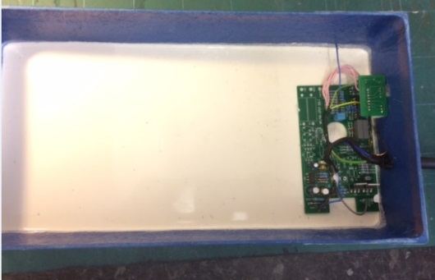 | 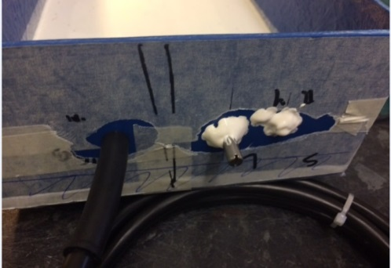
Stick Main PCB with few drops superglue and small PCB with the potentiometer nuts. Put silicon sealant around cable grommet and pots so when you pot it will not leak. | After you fit the Pots and Cable. Put Solder Mask (Rs 561-549) around the pots, Led’s and Power cable to prevent potting leaking when filling.  Fit baseplate to unit with masking Tape and Test the unit to make sure the unit works at correct range.
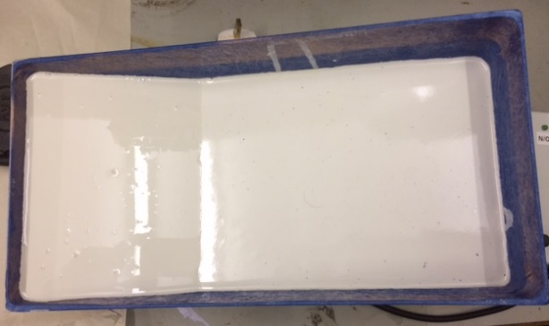 | 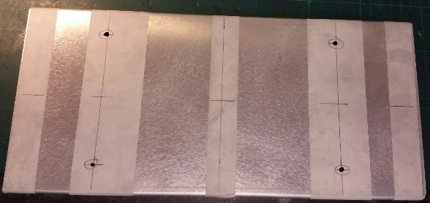  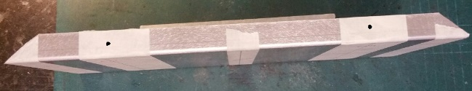
Place case on about 45° angle then cover the PCB with soft potting. Approx 600g Potting and 120g Activator. This should be enough to cover the Pcb and Wires. | Get the base plate and Mark up and drill 4 x 11mm holes for the unit fittings and 4 x 7mm holes for base plate inserters. Sometime you may have to cut base plate corners. If the case is longer then more Inserts maybe needed. Drill 4 x 5.5mm holes into fibre case for baseplate.
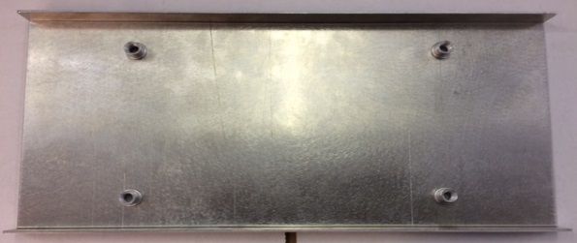  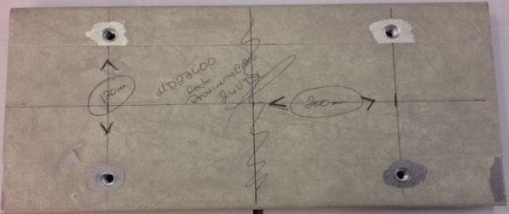 | 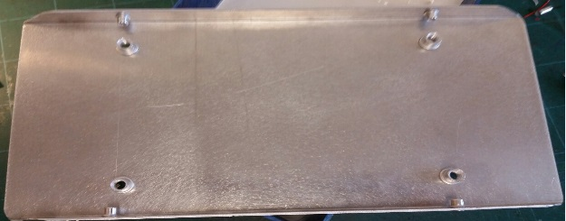  
Fix the 4 x M8 Thin sheet Rivet Nuts (CPC P/N: FN3027) | Fix the 4 x M5 Thin sheet Rivet Nuts (CPC P/N: FN3025).

PROCESS DESCRIPTION

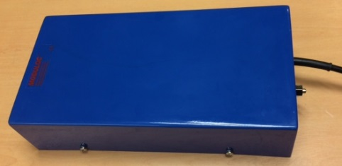 | 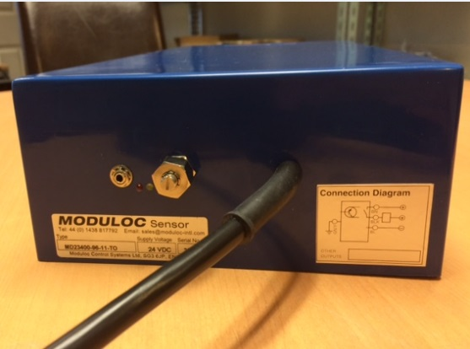
Fit the base plate on to case, using 4 x Pozi Pan M5x16mm (CPC P/N: FN00826) and 4 x M5 plain washer (CPC P/N: FN00786). | Connect the unit with power supply 24vDC or 110VAC dependant on unit you have built.  Now test the unit and set the range.
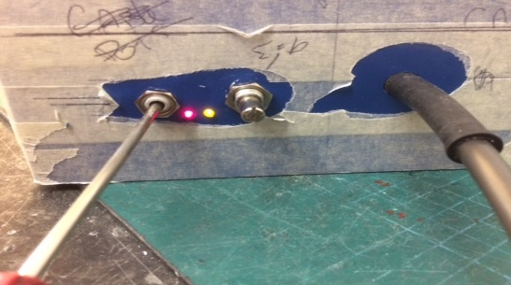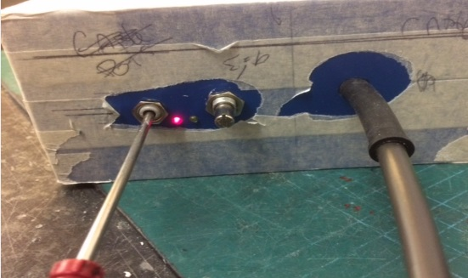  20k Coarse Pot  5k Pot | 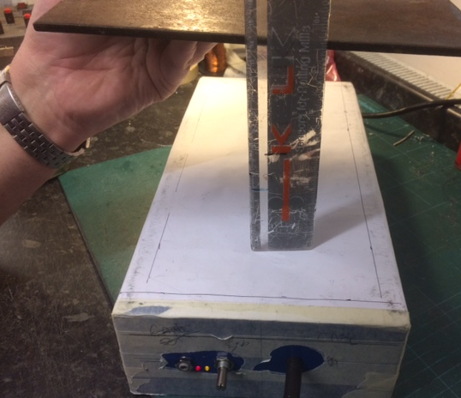
To Set up unit. Loosen 5k sense Height Pot lock-nut. Set Pot to mid position. Adjust Multiturn 20k pot (Coarse pot) clockwise until Yellow (Function Led) comes on then Anti-Clockwise till Yellow (Function Led) goes out. This should be approx mid position on pot. This is now set at Max sensing range. Retighten Lock Nut. | Place metal plate at 140mm from Sensor. Adjust Course Pot so yellow Function comes just on when Plate is sensed.

PROCESS DESCRIPTION

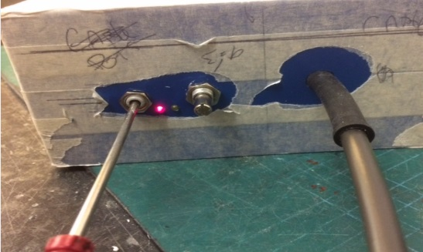 | 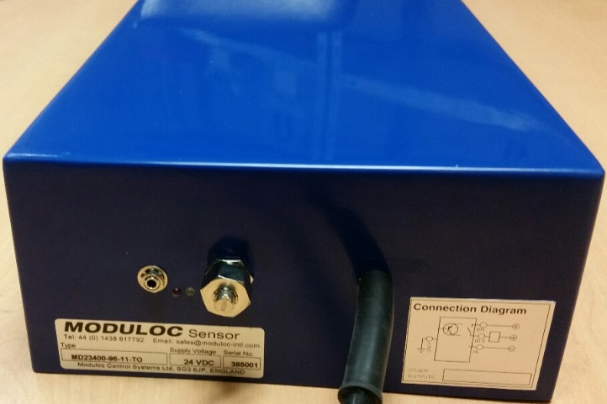
To Adjust to desired Range when in installed. Adjust Coarse Pot Anti-clockwise until desired range is achieved. | Print and fit desired Labels to the unit  1 x Part number 9000 Silver Label  1 x Wiring Diagram Label  1 x Red Moduloc Label

